A1354-US-MA-Plymouth-Rocky Hill-Grooved Axe-Archaic-Quartzite-c 5000 BCE

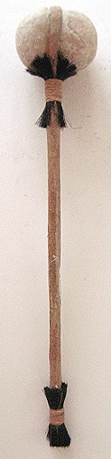 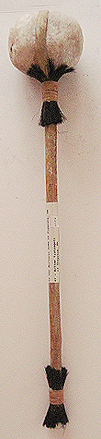 

**Case no.: 11**

**Accession Number: A1354**

**Formal Label:** US-MA-Plymouth-Rocky Hill-Axe-Archaic-Quartzite-c 5000 BCE

**Display Description:** This grooved quartzite axe was found on the historic collecting site of Watson’s or Rocky Hill, Plymouth, MA, by Arthur Vantangoli, Kingston, MA, 1946, and he hafted the stone quartzite grooved axe with rawhide. Horsehair tuffs (instead of human scalps) were placed at the intersection of the grooved axe and the handle and at the base of the handle. These horsehair tuffs or artificial “scalps” indicate that the axe was used in warfare and that the two tufts of scalp were evidence of the expertise of the owner having skill at “counting coup” or dispatching the enemy. The reason why this was interpreted as a weapon of war is that the “axe” had no cutting edge and that it had abrasions on all surfaces with one pock mark that indicated it had hit something hard and chipped a section.

**LC Classification: E78.N5**

**Date or Time Horizon:** 5000 BCE

**Geographical Area:** Plymouth, MA

**Map:**

Artist’s view of Gov. Bradford’s house in 1621 showing the burial hill to the upper left. After <https://www.gutenberg.org/files/57135/57135-h/images/p22a.jpg>



Revised artist’s view of the location of the Cantauganteest Indian village on Watson’s or Rocky Hill above the Plymouth Colony Plantation with its typical seventeenth-century diamond-shaped palisade and four bastions. After <https://player.slideplayer.com/27/9214511/data/images/img22.jpg>



Location of key points of interest in Plymouth. After https://www.gutenberg.org/files/57135/57135-h/images/map_lr.jpg

5. Court House.

6. Cole’s Hill.

7. Plymouth Rock.

8. Site of first house.

9. Burial Hill.

10. Pilgrim Spring.

11. Training Green.

12. Watson’s or Rocky Hill where there was the Indian village of Cantauganteest where this axe was found.

13. Pilgrim Wharf.

14. Town Brook.

15. Site of Gov. Bradford House.

16. Pilgrim Bookstore.

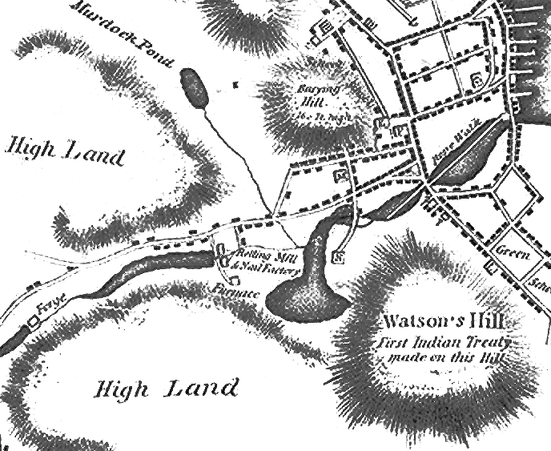

1680 Bourne Map of Plymouth, detailed view. After https://i2.wp.com/upload.wikimedia.org/wikipedia/commons/c/c1/1830_map_Plymouth_Massachusetts_byBourne_BPL_12878_detail.png?resize=450,300

**GPS coordinates:**

**Cultural Affiliation:** Maritime Archaic, 5000 BCE

**Media:** quartzite, rawhide, wood, horsehair

**Dimensions:**

**Weight:**

**Condition: original**

**Provenance:** Watson’s or Rocky Hill, Plymouth, MA, by Arthur Vantangoli, Kingston, MA, 194

**Discussion:**

**References:**